New regime

* No need to pay tax if salary < 7,00,000
* No deductions allowed

Old regime

* No need to pay tax if salary < 5,00,000

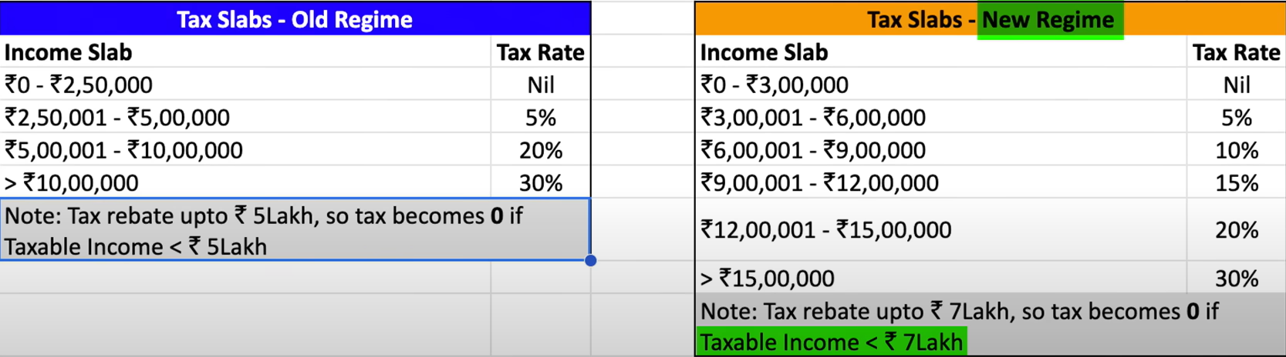

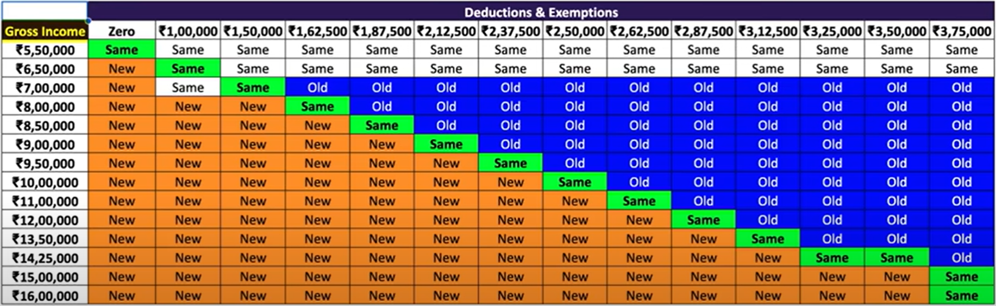

Exemption

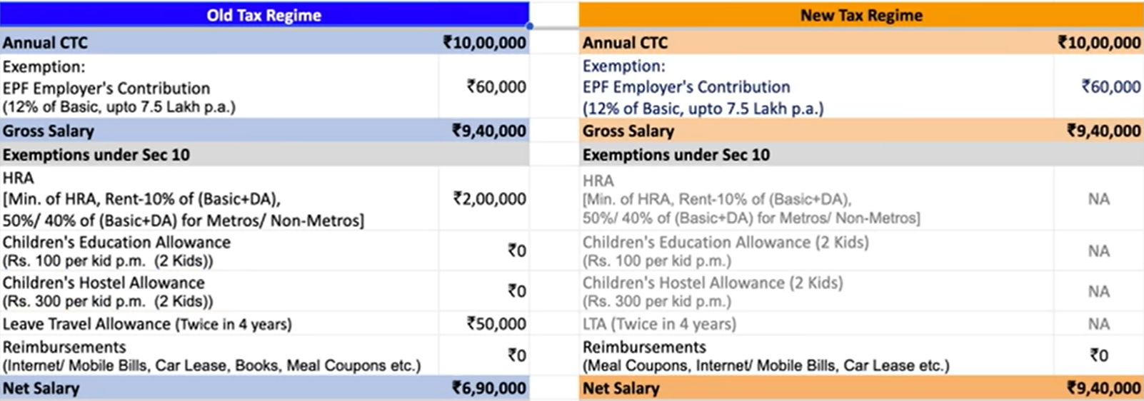

Upto a limit specified by employer’s offer letter

Deductions

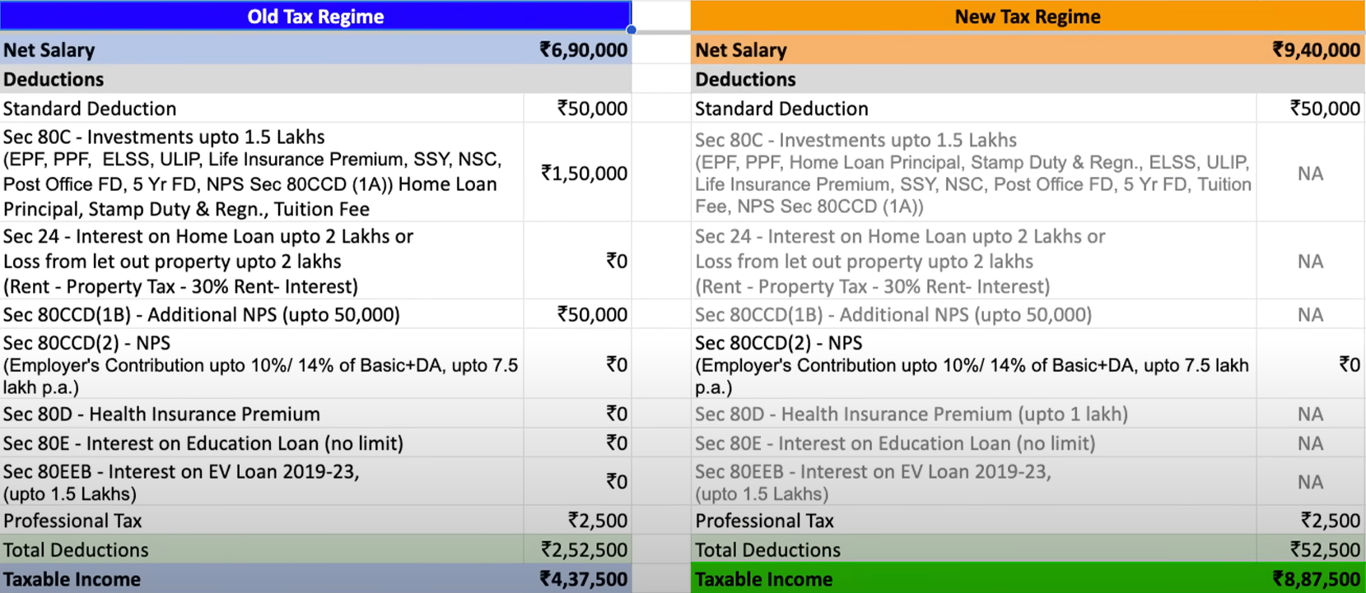

Cannot be combined with HRA in above exemption if both are in same city

 = net salary(6,90,000) – deductions(2,52,500)